ERFWeb Employee Filing Guide
Oct 23, 2026 · @Jay Bryan

Before you start
You need an ERFWeb account and Chrome or Edge; your administrator sets up everything else once.
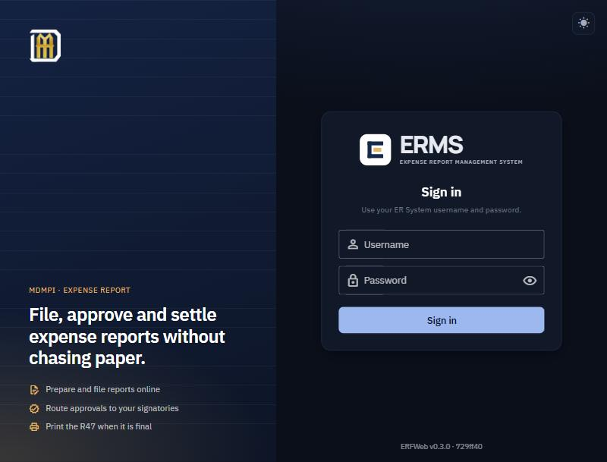
- Open ERFWeb and sign in with the username and temporary password you were given.
- On your first sign-in ERFWeb opens Change password. Choose your own: at least 8 characters, different from your username and from the temporary one.
- Ask your administrator to confirm these are set for you, or filing will be blocked:
  - your signature (printed on the R47),
  - your approvers (Level 1, and Level 2 if required),
  - your meal and allowance rates,
  - your mobile number and email, for notifications.
- New accounts can file only after a 3-day waiting period from registration. You can prepare drafts in the meantime.
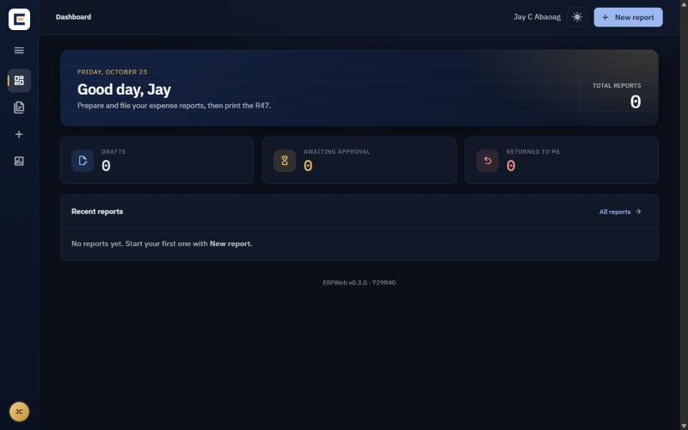
Safari on iPhone, iPad and Mac cannot sign in yet.

Step 1: Create the report
Start with the header; expense lines and receipts come after the report is created.
- In the left menu, click New report.
- Under Report type, pick one:
Report type | Use it when
Reimbursement | You paid out of pocket, with no cash advance; the full total is due to you
Liquidation of Cash Advance | You received a cash advance and are accounting for it
Replenishment of Revolving Fund | You hold a revolving fund and are topping it up
- Enter Date from and Date to, the period your expenses cover.
- Check the Purpose. ERFWeb fills it in for you (for example Reimbursement 10/01/2026 - 10/15/2026); type over it if you want different wording. It prints on the R47.
- For a Replenishment, enter the Revolving fund amount.
- Click Create report. The report opens in the editor as a draft (status New).
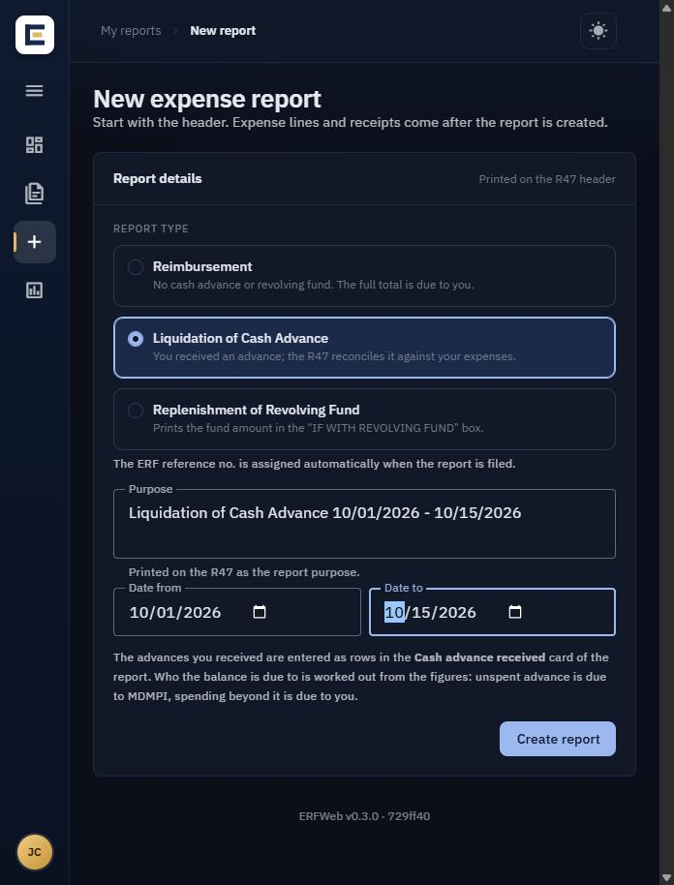
The ERF reference number (e.g. ERF-2026-000142) is assigned only when you file; drafts show "Assigned when filed".
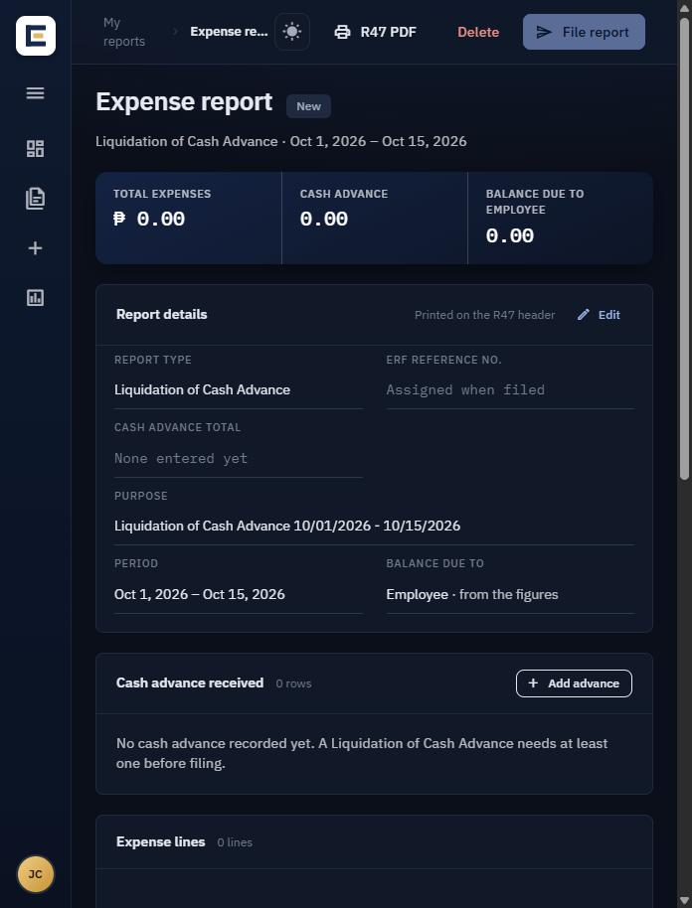

Step 2: Add expense lines
Add one line per expense; the Add expense line window shows the line total at the bottom as you type.
- In the report editor, click Add expense line (on a report that already has lines, the button reads Add line). The Add expense line window opens.
- Set the Date of the expense and choose Local or Foreign.
- Click a category: Meals, Transportation, Toll, Parking, Others or Representation. The window shows which R47 column the line goes into.
- Fill in Particulars (what it was, e.g. SUCAT - NICHOLS), Location (e.g. MDMPI, CALMC) and Work with (who you were with or the client; lines are grouped by it on the R47).
- Complete the part for your category:
  - Meals: tick the meals (Breakfast, Lunch, Dinner, OT Meal). Your rate for that date shows on each, and their total is filled in as the amount. If no rate shows, type the amount yourself.
  - Transportation: click Add leg for each ride. Choose the Mode (Taxi, Grab, Angkas, Jeepney and so on), then From, To and Fare. A new leg starts where the last one ended. Click Use as amount to copy the legs total into the amount.
  - Allowance by the day: tick Per-diem / allowance, enter the daily amount, the # of days and any − days taken off.
- Check the Amount. Use Multiplier for repeated identical expenses (e.g. 2 for two trips).
- If you have an official receipt, enter the Invoice / OR no.; only then can you enter a VAT amount.
- Optional: More details holds remarks, instrument, serial no. and service no.
- Click Add line. The window clears for the next line; close it when you are done.
A Meals line with Breakfast and Lunch ticked:
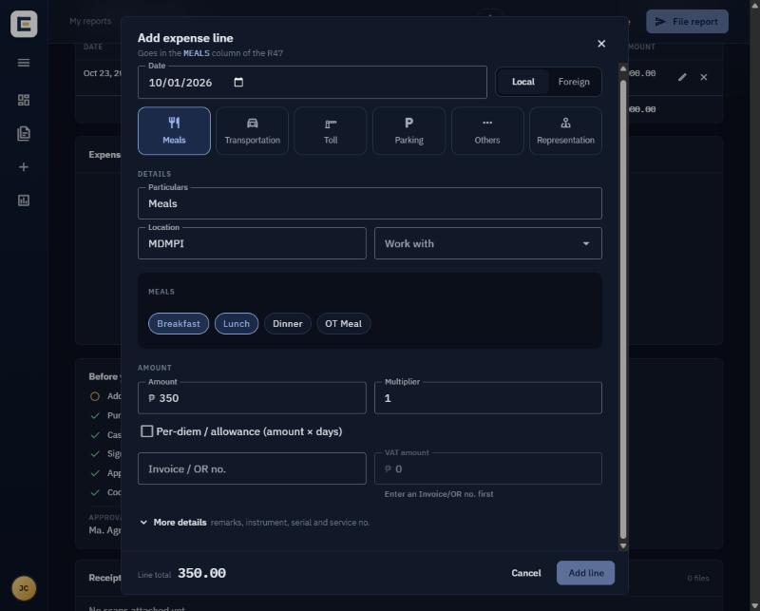
A Transportation line: pick the mode for each leg first.
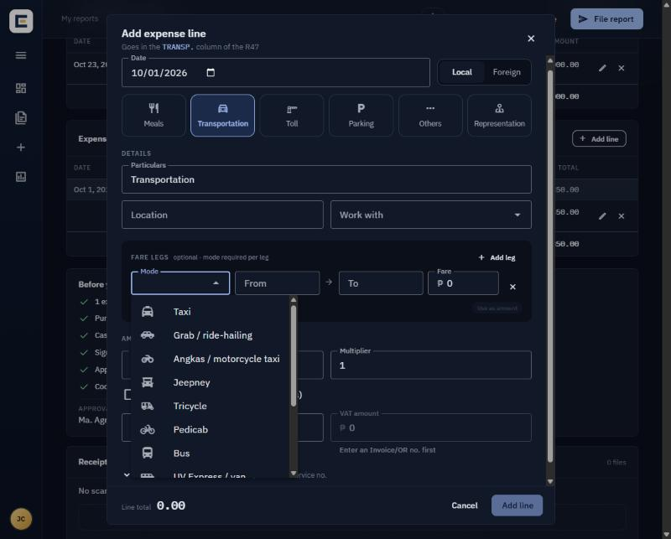
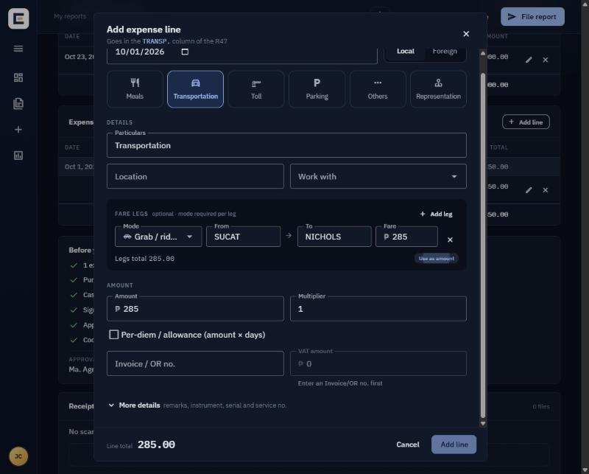
To change a line, open it from the expense lines table and click Save line. Lines with an OR number keep centavos; other lines round to whole pesos.

Step 3: Record cash advances (Liquidation only)
Only a Liquidation of Cash Advance needs this step; a Replenishment's fund amount was entered in Step 1, and a Reimbursement has neither.
- In the Cash advance received card, click Add advance.
- Enter the Date and Amount you received, the Reference document (e.g. Check Voucher, Petty Cash Voucher) and the Ref. no.
- Click Add advance. Repeat for each advance, then click Done.
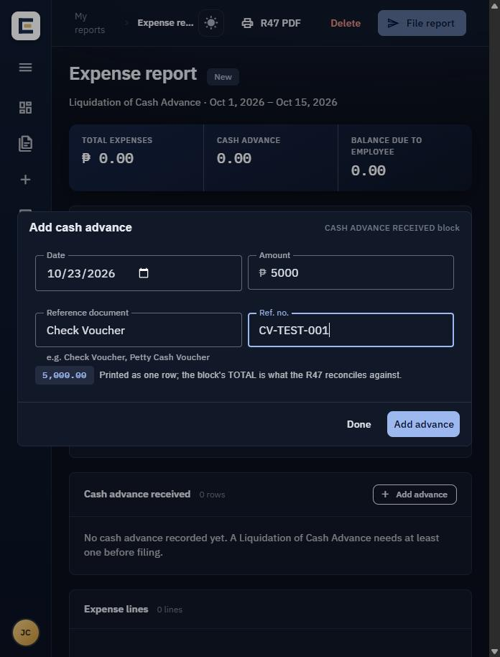
The R47 compares your advances with your expenses: unspent advance is due to MDMPI, spending beyond it is due to you.

Step 4: Attach receipts
Upload a scan or photo of every receipt in the Receipts card.
- Drag JPEG, PNG or PDF files onto the box, or click it to choose files (on a phone, tap it to take or pick a photo).
- Each file appears in the list; click its name to check it, or the × to delete it.
The Receipts card sits at the bottom of the report; it is shown in the Step 5 screenshot.
Uploads are a copy only: you must still give the original receipts to Finance after the report is approved.

Step 5: Check the list and file
The Before you file card shows every requirement: green ticks are done, amber circles still need attention. File report stays disabled until all are green.
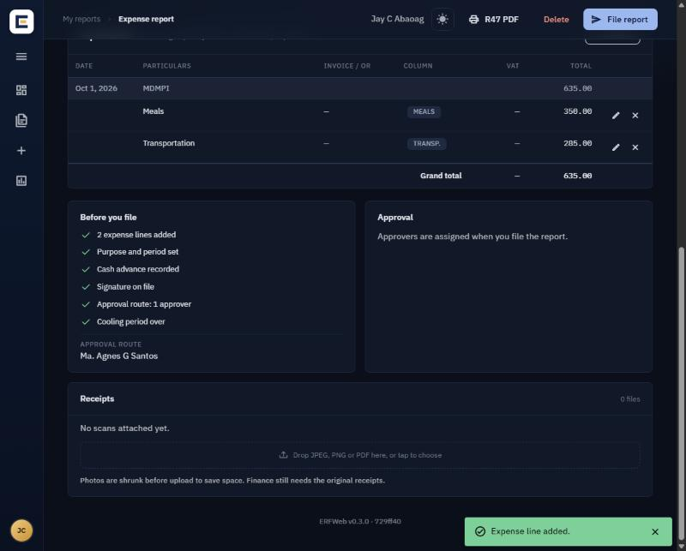
Checklist item | If it is amber
Expense lines added | Add at least one line (Step 2)
Purpose and period set | Fill in Purpose, Date from and Date to (Step 1)
Cash advance recorded (Liquidation) | Add at least one advance (Step 3)
Revolving fund amount recorded (Replenishment) | Enter it in the report details (Step 1)
Signature on file | Ask your administrator to upload your signature
Approval route | Ask your administrator to set your approvers
Cooling period over | Wait until the date shown
- Check the Approval route line at the bottom of the card; it names who will approve, in order.
- Open R47 PDF if you want to see the printed form first.
- Click File report, read the total in the confirmation, then click File report again.
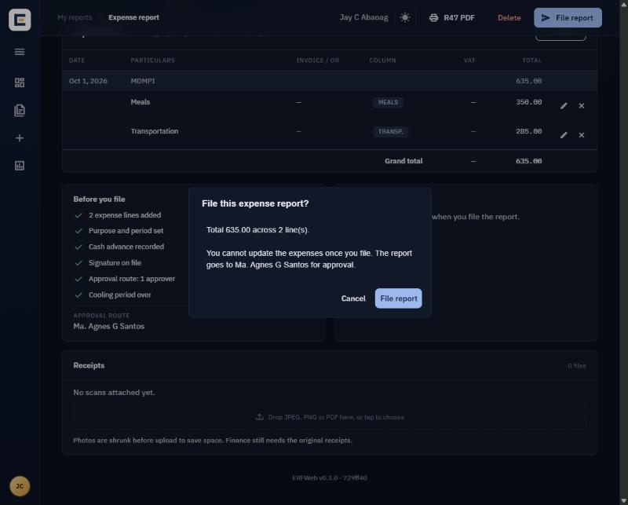
You cannot change expenses once you file. ERFWeb assigns the ERF reference number, shows Filed. Awaiting approval by …, and texts and emails you and your approvers.

After filing
Follow your report under My reports; open it to see the approval timeline. You get an SMS and an email at each approval, return or rejection.
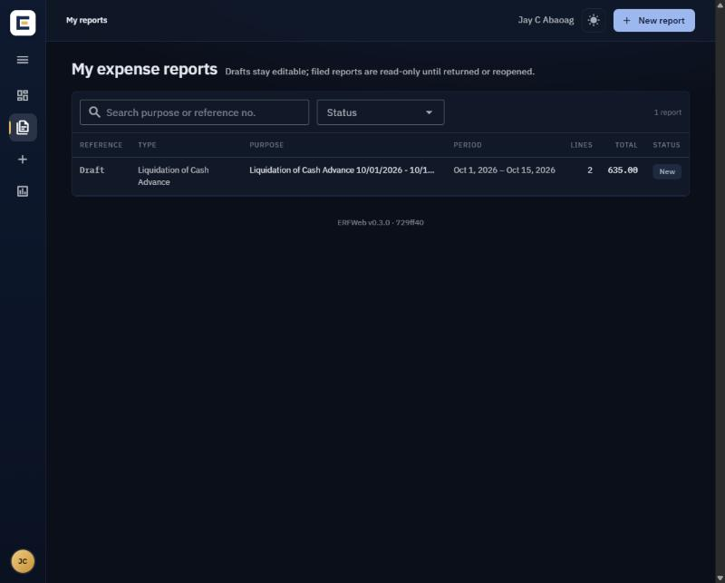
Status | What it means | What you do
For approval | Waiting for your approvers | Wait; you may Reopen it only until the first approver acts
Returned | An approver sent it back with a note | Read the note, fix the report, click Re-file report
Approved | All approvers signed | Hand the original receipts to Finance
Rejected | Final decision | Nothing; it cannot be re-filed
- Reopen: puts a filed report back to draft so you can change it; approval starts again from the first approver.
- R47 PDF: view, print or download the form, or Email it to yourself and your approvers.
- Delete: only drafts that were never filed can be deleted.

Common problems
What you see | What to do
File report is greyed out | Look for amber items in Before you file (Step 5)
"Signature not on file" or "No approval route is configured for you" | Ask your administrator to set it up
Meal rates show nothing or zero | Your rates are not set for that date; ask your administrator
"Choose a mode" on a fare leg | Pick the Mode for every leg you filled in
VAT amount is greyed out | Enter the Invoice / OR no. first
The page reloads after you save | Someone changed the report at the same time; redo your last change
Cannot edit a filed report | Reopen it (before an approver acts) or ask your approver to return it
"Too many failed sign-in attempts" | Wait 15 minutes, or ask the administrator to reset your password
Still stuck? Send the ERFWeb administrator the time, your report's reference number and any error shown on screen.

